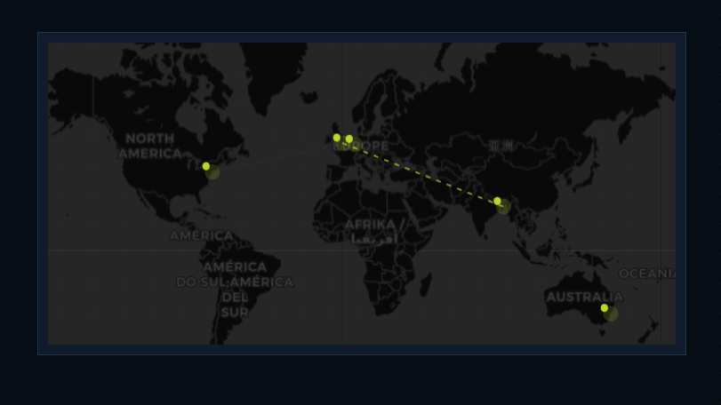

1.Glow mismatched. ( Homepage, Interactive Map page )

2. Client logo needed

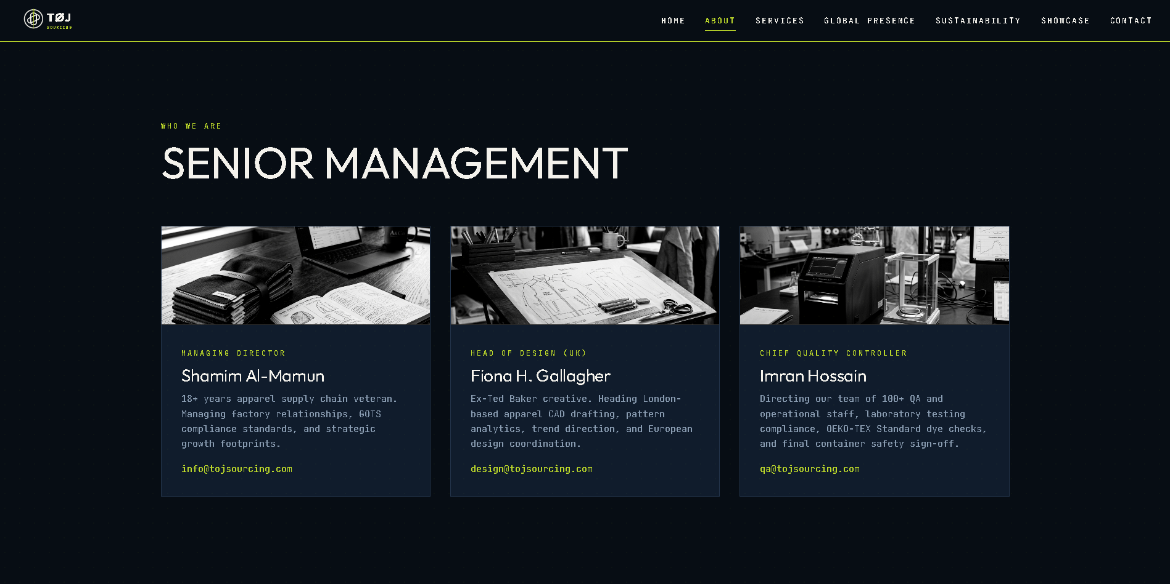
3. In about page no need for this section.

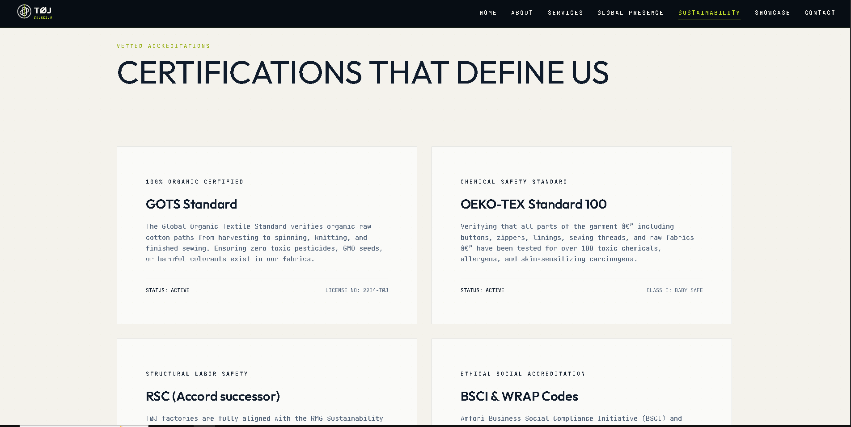
4. Logo required for the certification

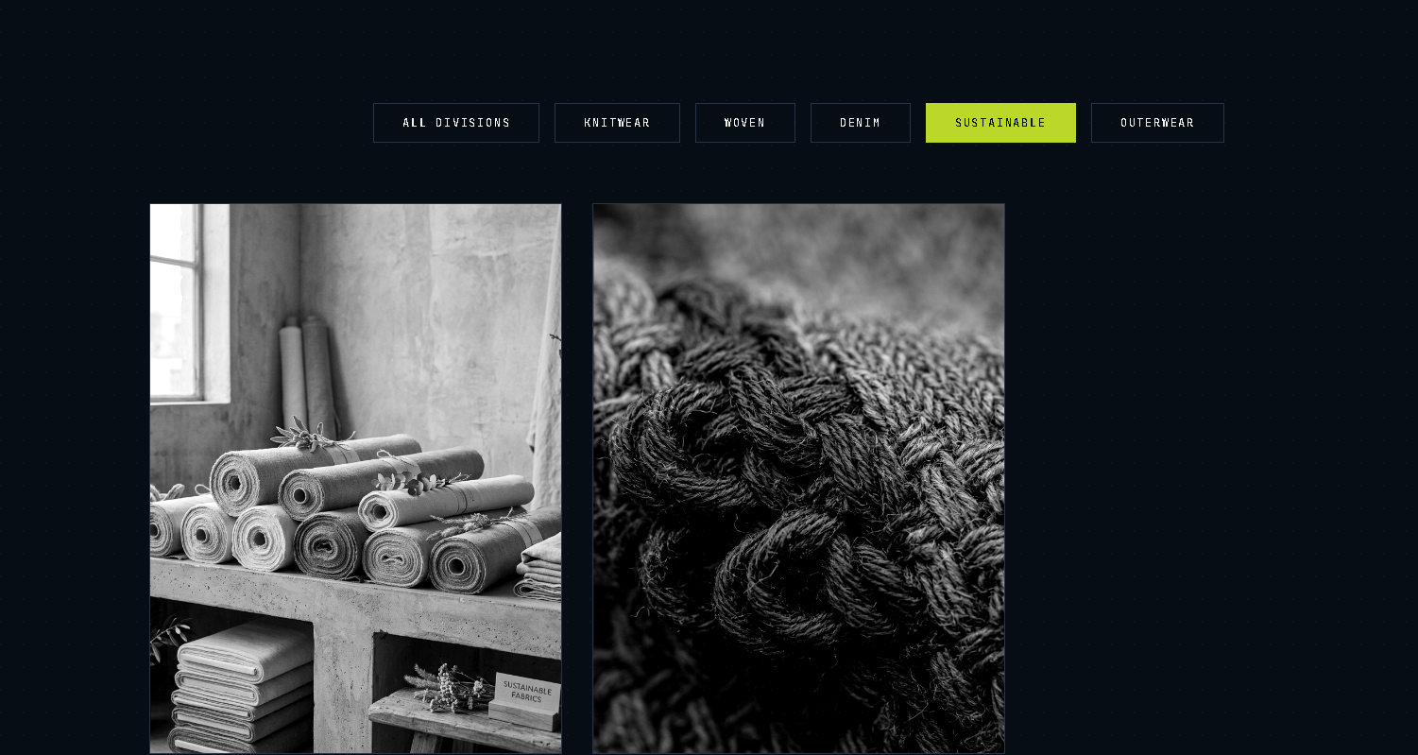
5. Remove sustainable in showcase page.


6. Footer and header logo needs to be bigger.


7. Nav Bar is missing from mobile format

8. Video Required in home page needs to be optimized for PC in all resolutions and Mobile

9. Preloader Required

